ASSIGNMENT LAB4

QUESTION 1 (CODE)

#include<iostream>

using namespace std;

int main(){

char a,b;

cout<<"Do you have ID card? (y/n)\n";

cin>>a;

if (a=='n'){

cout<<"You are not allowed to enter:\n";

}

if (a=='y'){

cout<<"What is your department\n";

cout<<"a=CS\n";

cout<<"b=BBA\n";

cout<<"c=EE\n";

cout<<"d=EDU\n";

cout<<"Enter your department:\n";

cin>>b;

}

if(b=='a'){

cout<<"CS department go to block 1\n";

}

if(b=='b'){

cout<<"BBA department go to block 2\n";

}

if(b=='c'){

cout<<"EE department go to block 3\n";

}

if(b=='d'){

cout<<"EDU department go to knowledge center\n";

}

return 0;

}

QUESTION 1 (OUTPUT)

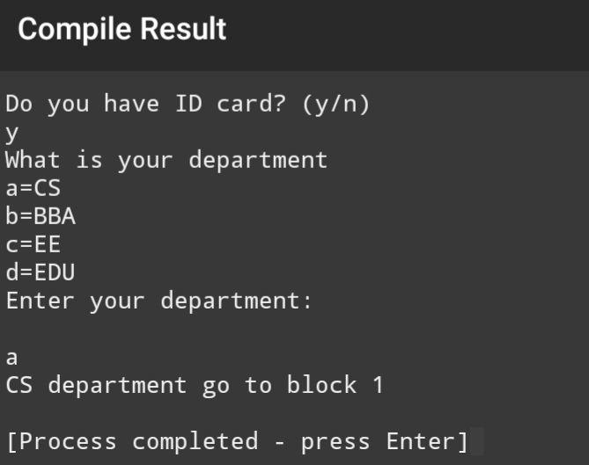

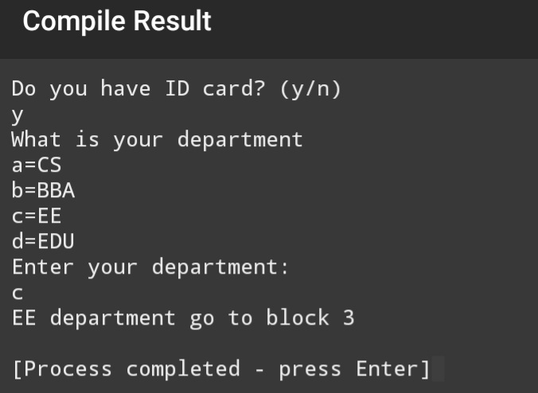

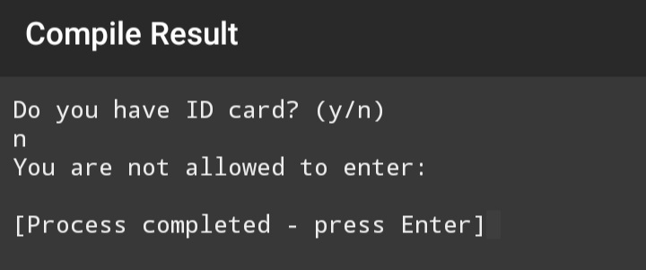

QUESTION 2(A) (CODE)

#include<iostream>

using namespace std;

int main(){

double x,y;

char operation;

cout<<"Enter first number:\n";

cin>>x;

cout<<"Enter second number:\n";

cin>>y;

cout<<"Enter the operator:\n";

cin>>operation;

switch(operation){

case '+':

cout<<"The addition of two number is "<<x+y<<endl;

break;

case '-':

cout<<"The substraction of two number is "<<x-y<<endl;

break;

case '\*':

cout<<"The multipication of two number is "<<x\*y<<endl;

break;

case '/':

cout<<"The division of two number is "<<x/y<<endl;

break;

default :

cout<<"Entered operator is invalid!";

}

return 0;

}

QUESTION 2(A) (OUTPUT)

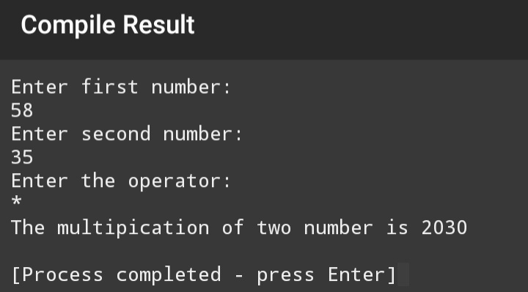

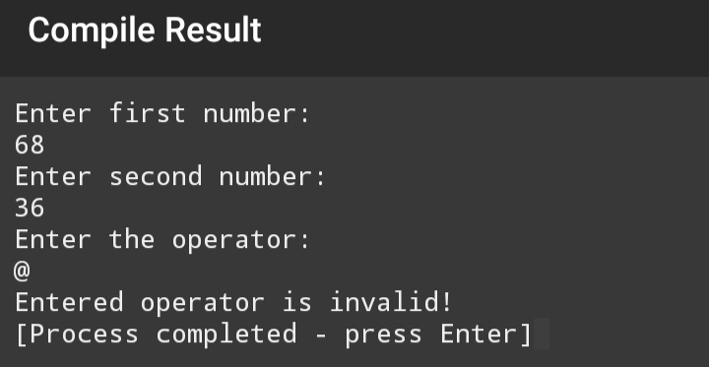

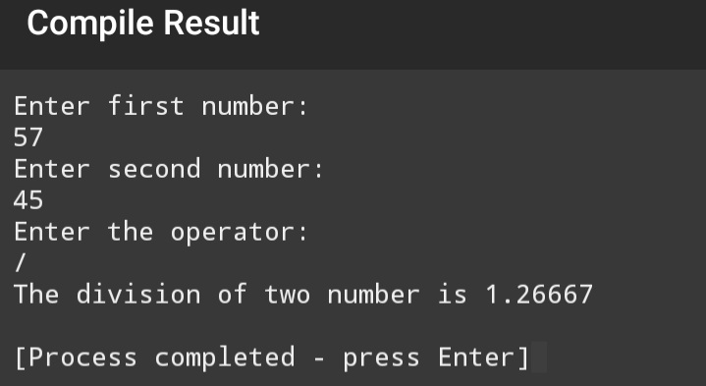

QUESTION 2(B) (CODE)

#include<iostream>

using namespace std;

int main(){

int a;

cout<<"Enter a number of month like(1 to 12).\n";

cin>>a;

switch(a){

case 1:

cout <<"It is january.\n";

break;

case 2:

cout <<"It is febuary.\n";

break;

case 3:

cout <<"It is march.\n";

break;

case 4:

cout <<"It is april.\n";

break;

case 5:

cout <<"It is may.\n";

break;

case 6:

cout <<"It is june.\n";

break;

case 7:

cout <<"It is july.\n";

break;

case 8:

cout <<"It is agust.\n";

break;

case 9:

cout <<"It is september.\n";

break;

case 10:

cout <<"It is october.\n";

break;

case 11:

cout <<"It is november.\n";

break;

case 12:

cout <<"It is december.\n";

break;

default:

cout<<"Invalid month number!\n"; }

return 0; }

QUESTION 2(B) (OUTPUT)

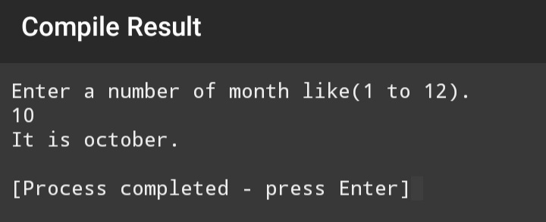

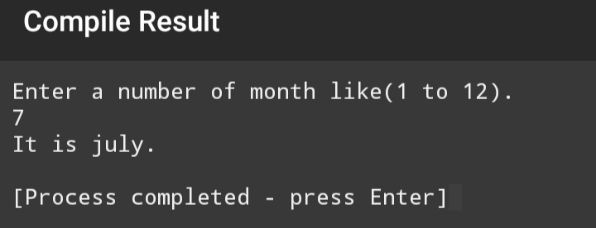

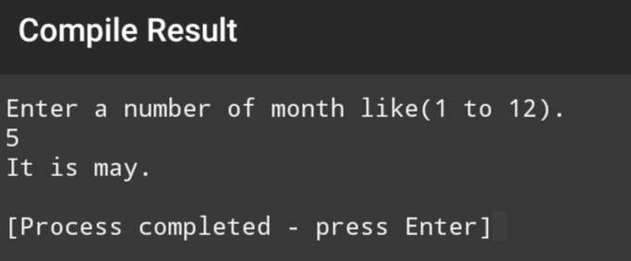

QUESTION 2(C) (CODE)

#include<iostream>

using namespace std;

int main(){

int a;

cout<<"Enter a number of month like(1 to 12).\n";

cin>>a;

switch(a){

case 1:

case 2:

case 12:

cout <<"It is winter season.\n";

break;

case 3:

case 4:

cout <<"It is spring season.\n";

break;

case 5:

case 6:

case 7:

case 8:

case 9:

cout <<"It is summer season.\n";

break;

case 10:

case 11:

cout <<"It is autumn season.\n";

break;

default:

cout<<"Invalid month number!\n"; }

return 0; }

QUESTION 2(C) (OUTPUT)

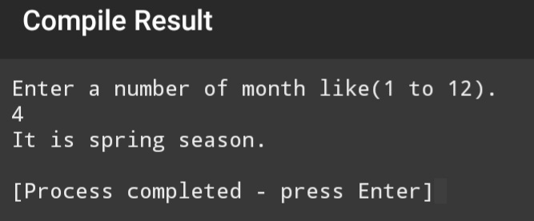

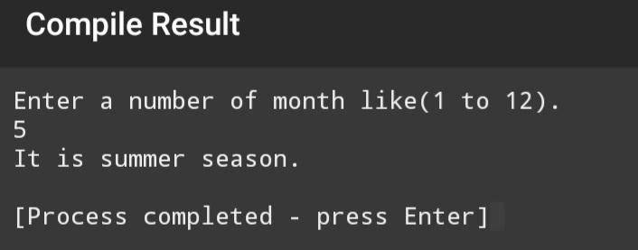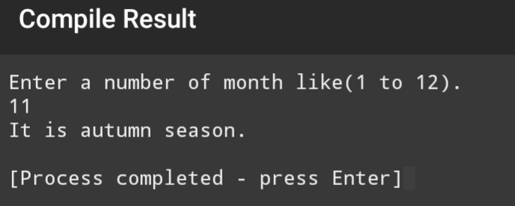

QUESTION 2(D) (CODE)

#include<iostream>

using namespace std;

int main()

{

char x;

cout<<"Enter a alphabet capital or small.\n";

cin>>x;

switch(x){

case 'a':

case 'e':

case 'i':

case 'o':

case 'u':

case 'A':

case 'E':

case 'I':

case 'O':

case 'U':

cout<<"It is a vowel letter\n";

break;

case 'b':

case 'c':

case 'd':

case 'f':

case 'g':

case 'h':

case 'j':

case 'k':

case 'l':

case 'm':

case 'n':

case 'p':

case 'q':

case 'r':

case 's':

case 't':

case 'v':

case 'w':

case 'x':

case 'y':

case 'z':

case 'B':

case 'C':

case 'D':

case 'F':

case 'G':

case 'H':

case 'J':

case 'K':

case 'L':

case 'M':

case 'N':

case 'P':

case 'Q':

case 'R':

case 'S':

case 'T':

case 'V':

case 'W':

case 'X':

case 'Y':

case 'Z':

cout<<"It is a consonant letter\n";

}

return 0;

}

QUESTION 2(D) (OUTPUT)

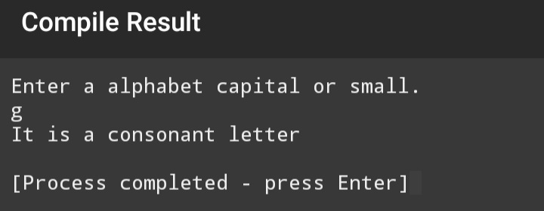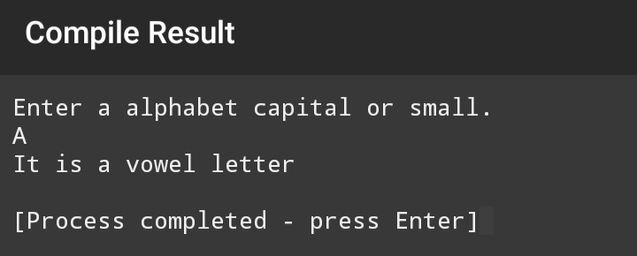

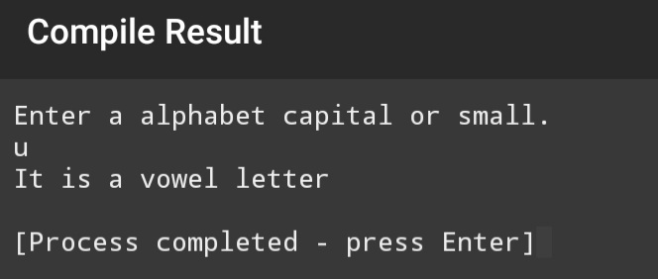

QUESTION 2(E) (CODE)

#include<iostream>

using namespace std;

int main()

{

int x;

cout << "Enter a number.\n";

cin>>x;

switch(x%2){

case 0:

cout<<"It is a even number\n";

break;

case 1:

cout<<"It is a odd number\n";

}

return 0;

}

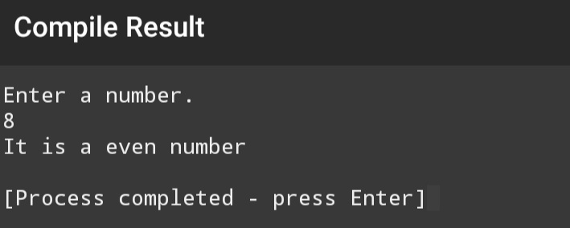QUESTION 2(E) (OUTPUT)

